## ****UNIT-V****

### ****FEEDER PROTECTION:****

The probability of faults occurring on the lines is much more due to their greater length and exposure to atmospheric conditions. This has called for many protective schemes which have no application to the comparatively simple cases of alternators and transformers. The requirements of line protection are :

* **In the event of a short-circuit, the circuit breaker closest to the fault should open, all other circuit breakers remaining in a closed position.**
* **In case the nearest breaker to the fault fails to open, back-up protection should be provided by the adjacent circuit breakers.**
* **The relay operating time should be just as short as possible in order to preserve system stability, without unnecessary tripping of circuits.**

The protection of lines presents a problem quite different from the protection of station apparatus such as generators, transformers and Busbar Protection. While differential protection is ideal method for lines, it is much more expensive to use. The two ends of a line may be several kilometers apart and to compare the two currents, a costly pilot-wire [circuit](http://www.allaboutcircuits.com/) is required. This expense may be justified but in general less costly methods are used. The common methods of line protection are :

* **Time-graded overcurrent protection**
* **Differential protection**
* **Distance protection**

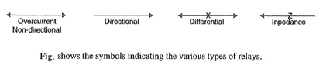

## ****Time Graded Overcurrent Protection:****

In this scheme of Time Graded Overcurrent Protection, time discrimination is incorporated. In other words, the time setting of relays is so graded that in the event of fault, the smallest possible part of the system is isolated. We shall discuss a few important cases.

**1. Radial feeder:** The main characteristic of a radial system is that power can flow only in one direction, from generator or supply end to the load. It has the disadvantage that continuity of supply cannot be maintained at the receiving end in the event of fault. Time Graded Overcurrent Protection protection of a radial feeder can be achieved by using

* **Definite time relays and**
* **Inverse time relays.**

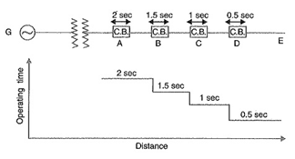

**(i) Using definite time relays:** Fig shows the overcurrent protection of a radial feeder by definite time relays. The tisme of operation of each relay is fixed and is independent of the operating current. Thus relay D has an operating time of 0.5 second while for other relays, time delay is successively increased by 0.5 second. If a fault occurs in the section DE, it will be cleared in 0.5 second by the relay and circuit breaker at D because all other relays have higher operating time. In this way only section DE of the system will be isolated. If the relay at D fails to trip, the relay at C will operate after a time delay of 0.5 second i.e. after 1 second from the occurrence of fault.

The disadvantage of this system is that if there are a number of feeders in series, the tripping time for faults near the supply end becomes high (2 seconds in this case). However, in most cases, it is necessary to limit the maximum tripping time to 2 seconds. This disadvantage can be overcome to a reasonable extent by using inverse-time relays.

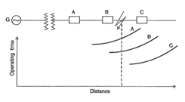

**(ii) Using inverse lime relays:** Fig shows overcurrent protection of a radial feeder using inverse time relays in which operating time is inversely proportional this arrangement, the farther the circuit breaker from the generating operating time.

The three relays at A, B and C are assumed to have inverse-time characteristics. A fault in section BC will give relay times which will allow breaker at B to trip out before the breaker at A.

**2. Parallel feeders:** Where continuity of supply is particularly necessary, two parallel feeders may be installed. If a fault occurs on one feeder, it can be disconnected from the system and continuity of supply can be maintained from the other feeder. The parallel feeders cannot be protected by non-directional overcurrent relays only. It is necessary to use directional relays also and to grade the time setting of relays for selective trippings.

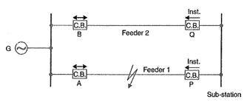

Fig. shows the system where two feeders are connected in parallel between the generating station and the sub-station. The protection of this system requires that

* **each feeder has a non-directional overcurrent relay at the generator end. These relays should have inverse-time characteristic.**
* **each feeder has a reverse power or directional relay at the sub-station end. These relays should be instantaneous type and operate only when power flows in the reverse direction e. in the direction of arrow at P and Q.**

Suppose an earth fault occurs on feeder 1 as shown in Fig. It is desired that only circuit breakers at A and P should open to clear the fault whereas feeder 2 should remain intact to maintain the continuity of supply. In fact, the above arrangement accomplishes this job. The shown fault is fed via two routes, viz.

* **Directly from feeder 1 via the relay A**
* **From feeder 2 via B, Q, sub-station and P**

Therefore, power flow in relay Q will be in normal direction but is reversed in the relay P. This causes the, opening of circuit breaker at P. Also the relay A will operate while relay B remains inoperative. It is because these relays have inverse-time characteristics and current flowing in relay A is in excess of that flowing in relay B. In this way only the faulty feeder is isolated.

**3. Ring main system:** In this system, various power stations or sub-stations are intercon­nected by alternate routes, thus forming a closed ring. In case of damage to any section of the ring, that section may be disconnected for repairs, and power will be supplied from both ends of the ring, thereby maintaining continuity of supply.

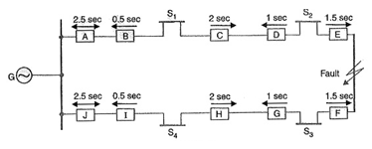

Fig. shows the single line diagram of a typical ring main system consisting of one generator G supplying four sub-stations S1, S2, S3 and S4. In this arrangement, power can flow in both directions under fault conditions. Therefore, it is necessary to grade in both directions round the ring and also to use directional relays. In order that only faulty section of the ring is isolated under fault conditions, the types of relays and their time settings should be as follows :

* The two lines leaving the generating station should be equipped with non-directional overcurrent relays (relays at A and J in this case).
* At each sub-station, reverse power or directional relays should be placed in both incoming and outgoing lines (relays at B, C, D, E, F, G, H and I in this case).
* There should be proper relative time-setting of the relays. As an example, going round the loop G S1 S2 S3 S4 G ; the outgoing relays (viz at A, C, E, G and I) are set with decreasing time limits e.g.

[Time Graded Overcurrent Protection](https://www.eeeguide.com/wp-content/uploads/2018/06/Time-Graded-Overcurrent-Protection-4.jpg)

Similarly, going round the loop in the opposite direction (i.e. along G S1 S2 S3 S4 G), the outgoing relays (J, H, F, D and B) are also set with a decreasing time limit e.g.

[Time Graded Overcurrent Protection](https://www.eeeguide.com/wp-content/uploads/2018/06/Time-Graded-Overcurrent-Protection-5.jpg)

Suppose a short circuit occurs at the point as shown in Fig. In order to ensure selectivity, it is desired that only circuit breakers at E and F should open to clear the fault whereas other sections of the ring should be intact to maintain continuity of supply. In fact, the above arrangement accomplishes this job. The power will be fed to the [fault](http://www.allaboutcircuits.com/) via two routes viz (i) from G around S1 and S2 and (ii) from G around S4 and S3. It is clear that relays at A, B, C and D as well as J, I, H and G will not trip. Therefore, only relays at E and F will operate before any other relay operates because of their lower time-setting

## ****Differential Pilot Wire Protection:****

The Differential Pilot Wire Protection is based on the principle that under normal conditions, the current entering one end of a line is equal to that leaving the other end. As soon as a fault occurs between the two ends, this condition no longer holds and the difference of incoming and outgoing currents is arranged to flow through a relay which operates the circuit breaker to isolate the faulty line. There are several Differential Pilot Wire Protection schemes in use for the lines. However, only the following two schemes will be discussed

#### ****Merz-Price voltage balance system****

#### ****Translay scheme****

**1. Men-Price voltage balance system:** Fig. shows the single line diagram of Merz­Price voltage balance system for the protection of a 3-phase line. Identical current transformers are placed in each phase at both ends of the line. The pair of CTs in each line is connected in series with a relay in such a way that under, normal conditions, their secondary voltages are equal and in opposi­tion i.e. they balance each other.

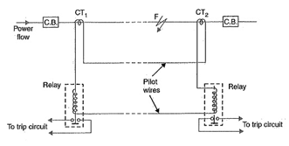

Under healthy conditions, current entering the line at one-end is equal to that leaving it at the other end. Therefore, equal and opposite voltages are induced in the secondaries of the CTs at the two ends of the line. The result is that no current flows through the relays. Suppose a fault occurs at point F on the line as shown in Fig. This will cause a greater current to flow through CT1 than through CT2. Consequently, their secondary voltages become unequal and circulating current flows through the pilot wires and relays. The circuit breakers at both ends of the line will trip out and the faulty line will be isolated.

Fig. shows the connections of Merz-Price voltage balance scheme for all the three phases of the line.

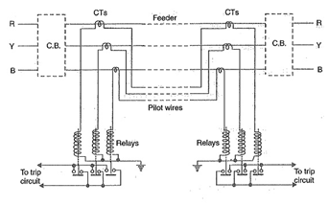

#### ****Advantages of Differential Pilot Wire Protection:****

* **This system can be used for ring mains as well as parallel feeders,**
* **This system provides instantaneous protection for ground faults. This decreases the possi­bility of these faults involving other phases.**
* **This system provides instantaneous relaying which reduces the amount of damage to over­head conductors resulting from arcing faults.**

#### ****Disadvantages of Differential Pilot Wire Protection:****

* **Accurate matching of current transformers is very essential.**
* **If there is a break in the pilot-wire circuit, the system will not operate.**
* **This system is very expensive owing to the greater length of pilot wires required.**
* **In case of long lines, charging current due to pilot-wire capacitance effects may be sufficient to cause relay operation even under normal conditions.**
* **This system cannot be used for line voltages beyond 33 kV because of constructional diffi­culties in matching the current transformers.**

**2. Translay scheme:** This system is similar to voltage balance system except that here balance or opposition is between the voltages induced in the secondary windings wound on the relay magnets and not between the secondary voltages of the line current transformers. This permits to use current transformers of normal design and eliminates one of the most serious limitations of original voltage balance system, namely ; its limitation to the system operating at voltages not exceeding 33 kV.

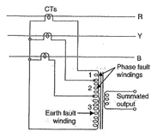

**Constructional details:** Fig. shows the simplified diagram illustrating the principle of *Translay scheme. It consists of two identical double winding induction type relays fitted at either end of the feeder to be protected. The primary circuits (11, 11a) of these relays are supplied through a pair of current transformers. The secondary windings (12, 13 and 12a, 13a) of the two relays are connected in series by pilot wires in such a way that voltages induced in the former opposes the other. The compensating devices (18, 18a) neutralise the effects of pilot-wire capacitance currents and of inherent lack of balance between the two current transformers. Operation. Under healthy conditions, current at the two ends of the protected feeder is the same and the primary windings (11, 11a) of the relays carry the same current. The windings 11 and 11a induce equal e.m.f.s in the secondary windings 12, 12a and 13, 13a. As these windings are so connected that their induced voltages are in opposition, no current will flow through the pilots or operating coils and hence no torque will be exerted on the disc of either relay. In the event of fault on the protected feeder, current leaving the feeder will differ from the current entering the feeder. Consequently, unequal voltages will be induced in the secondary windings of the relays and current will circulate between the two windings, causing the torque to be exerted on the disc of each relay. As the direction of secondary current will be opposite in the two relays, therefore, the torque in one relay will tend to close the trip circuit while in the other relay, the torque will hold the movement in the normal unoperated position. It may be noted that resulting operating torque depends upon the position and nature of the fault in the protected zone and atleast one element of either relay will operate under any fault condition.

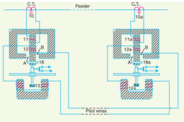

It is worthwhile here to mention the role of closed copper rings (18, 18a) in neutralising the effects of pilot capacitive currents. Capacitive currents lead the voltage impressed across the pilots by 90º and when they flow in the operating winding 13 and 13a (which are of low inductance), they produce fluxes that also lead the pilot voltage by 90º. Since pilot voltage is that induced in the secondary windings 12 and 12a, it lags by a substantial angle behind the fluxes in the field magnet air gaps A and B. The closed copper rings (18, 18a) are so adjusted that this angle is approximately 90º. In this way fluxes acting on the disc are in phase and hence no torque is exerted on the relay disc.

The application of Translay scheme for a single phase line has already been discussed in Art. This can be extended to 3-phase system by applying one relay at each end of each phase of the 3-phase line. However, it is possible to make fur her simplification by combining currents derived from all phases in a single relay at each end, using he principle of **summation transformer** . A summation transformer is a device that reproduces the poly phase line currents as a single-phase quantity. The three lines CTs are connected to the tapped primary of summation transformer. Each line. CT energizes a different number of turns (from line to neutral) with a resulting single phase output. The use of summation transformer permits two advantages viz (i) primary windings 1 and 2 can be used for phase faults whereas winding 3 can be used for earth fault (ii) the number of pilot wires required is only two.

**Schematic arrangement:** The Translay scheme for the protection of a 3-phase line is shown in Fig. The relays used in the scheme are essentially overcurrent induction type relays. Each relay has two electromagnetic elements. The upper element carries a winding (11 or 11 a) which is energized as a summation transformer from the secondaries of the line CTs connected in the phases of the line to be protected. The upper element also carries a secondary winding (12 or 12 a) which is connected is series with the operating winding (13 or 13 a) on the lower magnet. The secondary windings 12, 12 a and operating windings 13, 13 a are connected in series in such a way that voltages induced in them oppose each other.. Note that relay discs and tripping circuits have been omitted in the diagram for clarity.

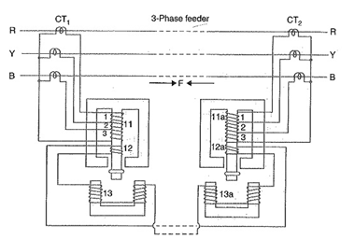

**Operation:** When the feeder is sound, the currents at its two ends are equal so that the secondary currents in both sets of CTs are equal. Consequently, the currents flowing in the relay primary wind­ing 11 and 11 a will be equal and they will induce equal voltages in the secondary windings 12 and 12a. Since these windings are connected in opposition, no current flows in them or in the operating windings 13 and 13a. In the event of a fault on the protected line, the line current at one end must carry a greater current than that at the other end. The result is that voltages induced in the secondary windings 12 and 12 a will be different and the current will flow through the operating coils 13, 13a and the pilot circuit. Under these conditions, both upper and lower elements of each relay are energised and a forward [torque](http://www.allaboutcircuits.com/) acts on the each relay disc. The operation of the relays will open the circuit breakers at both ends of the line.

* **Suppose a fault F occurs between phases R and Y and is fed from both sides as shown in Fig. This will energise only section 1 of primary windings 11 and 11a and induce voltages in the secondary windings 12 and 12a. As these voltages are now additive, therefore, current will circulate through operating coils 13, 13a and the pilot circuit. This will cause the relay contacts to close and open the circuit breakers at both ends. A fault between phases Y and B energises section 2 of primary windings 11 and 11a whereas that between R and B will energise the sections 1 and 2.**
* Now imagine that an earth fault occurs on phase R. This will energize sections 1, 2 and 3 of the primary windings 11 and 11a. Again if fault is fed from both ends, the voltages induced in the secondary windings 12 and 12a are additive and cause a current to flow through the operating coils 13, 13a. The relays, therefore, operate to open the circuit breakers at both ends of the line. In the event of earth fault on phase Y, sections 2 and 3 of primary winding 11 and 11a will be energised and cause the relays to operate. An earth fault on phase B will energise only section 3 of relay primary windings 11 and 11a.

#### **Advantages**

* **The system is economical as only two pilot wires are required for the protection of a 3-phase line.**
* **Current transformers of normal design can be used.**
* **The pilot wire capacitance currents do not affect the operation of relays.**

## ****Distance Protection:****

Both time-graded and pilot-wire system are not suitable for the protection of very long high voltage transmission lines. The former gives an unduly long time delay in fault clearance at the generating station end when there are more than four or five sections and the pilot-wire system becomes too expensive owing to the greater length of pilot wires required. This has led to the development of Distance Protection in which the action of relay depends upon the distance (or impedance) between the point where the relay is installed and the point of fault. This system provides discrimination protection without employing pilot wires.

The principle and operation of Distance Protection relays have already been discussed here. We shall now consider its application for the protection of transmission lines. Fig. (i) shows a simple system consisting of lines in series such that power can flow only from left to right.

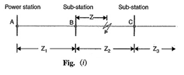

The relays at A, B and C are set to operate for impedance less than Z1 , Z2 and Z3respectively. Suppose a fault occurs between sub-stations B and C, the fault impedance at power station and sub-station A and B will be Z1 + Z and Z respectively. It is clear that for the portion shown, only relay at B will operate. Similarly, if a fault occurs within section AB, then only relay at A will operate. In this manner, instantaneous protection can be obtained for all conditions of operation.

In actual practice, it is not possible to obtain instantaneous protection for complete length of the line due to inaccuracies in the relay elements and instrument transformers. Thus the relay at A would not be very reliable in distinguishing between a fault at 99% of the distance AB and the one at 101% of distance AB. This difficulty is overcome by using ‘**three-zone**‘ Distance Protection shown in Fig. (ii).

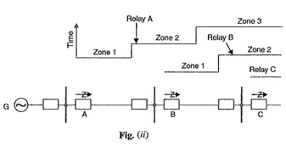

In this scheme of Distance Protection, three distance elements are used at each terminal. The zone 1 element covers first 90% of the line and is arranged to trip instantaneously for faults in this portion. The zone 2 element trips for faults in the remaining 10% of the line and for faults in the next line section, but a time delay is introduced to prevent the [line](http://www.allaboutcircuits.com/) from being tripped if the fault is in the next section. The zone 3 element provides back-up protection in the event a fault in the next section is not cleared by its breaker.

## ****BUSBAR PROTECTION:****

Busbars and lines are important elements of electric power system and require the immediate attention of protection engineers for safeguards against the possible faults occurring on them. The methods used for the protection of generators and transformers can also be employed, with slight modifications, for the busbars and lines. The modifications are necessary to cope with the protection problems wising out of greater length of lines and a large number of circuits connected to a Busbar Protection. Although differential protection can be used it becomes too expensive for longer lines due to the greater length of pilot wires required. Fortunately, less expensive methods are available which are reasonably effective in providing protection for the busbars and lines. In this chapter, we shall focus our attention on the various methods of protection of busbars and lines.

Busbar Protection in the generating stations and sub-stations form important link between the incoming and outgoing circuits. If a fault occurs on a busbar, considerable damage and disruption of supply will occur unless some form of quick-acting automatic protection is provided to isolate the faulty busbar. The busbar zone, for the purpose of protection, includes not only the busbars themselves but also the isolating switches, circuit breakers and the associated connections. In the event of fault on any section of the busbar, all the circuit equipment connected to that section must be tripped out to give complete isolation.

The standard of construction for Busbar Protection has been very high, with the result that bus faults are extremely rare. However, the possibility of damage and service interruption from even a rare bus fault is so great that more attention is now given to this form of protection. Improved relaying methods have been developed, reducing the possibility of incorrect operation.

The two most com­monly used schemes for busbar protection are :

#### ****Differential Protection****

#### ****Fault Bus Protection****

**1. Differential Protection:** The basic method for busbar protection is the differential scheme in which currents entering and leaving the bus are totalised. During normal load condition, the sum of these currents is equal to zero. When a fault occurs, the fault current upsets the balance and produces a differential current to operate a relay.

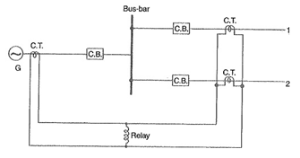

Fig. shows the single line diagram of current differential scheme for a station busbar. The Busbar Protection is fed by a generator and supplies load to two lines. The secondaries of current transformers in the generator lead, in line 1 and in line 2 are all connected in parallel. The protective relay is connected across this parallel connection. All CTs must be of the same ratio in the scheme regardless of the capacities of the various circuits. Under normal load conditions or external fault conditions, the sum of the currents entering the bus is equal to those leaving it and no current flows through the relay. If a fault occurs within the protected zone, the currents entering the bus will no longer be equal to those leaving it. The difference of these currents will flow through the relay and cause the opening of the generator, circuit breaker and each of the line circuit breakers.

**2. Fault Bus Protection:** It is possible to design a station so that the faults that develop are mostly earth-faults. This can be achieved by providing earthed metal barrier (known as **fault bus**) surrounding each conductor throughout its entire length in the bus structure. With this arrangement, every fault that might occur must involve a connection between a conductor and an earthed metal By directing the flow of earth-fault current, it is possible to detect the faults and determine their location. This type of protection is known as fault bus protection.

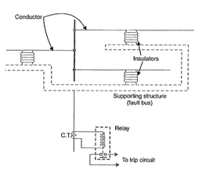

Fig. show the schematic arrangement of fault bus protection. The metal supporting structure or fault bus is earthed through a current transformer. A relay is connected across the secondary of this CT. Under normal operating conditions, there is no current flow from fault bus to ground and the relay remains inoperative. A fault involving a connection between a conductor and earthed supporting structure will result in current flow to ground through the fault bus, causing the relay to operate. The operation of relay will trip all breakers connecting equipment to the bus.

## ****PROTECTION OF ALTERNATORS:****

The generating units, especially the larger ones, are relatively few in number and higher in individual cost than most other equipment’s. Therefore, it is desirable and necessary to provide Protection of Alternators to cover the wide range of faults which may occur in the modern generating plant.

Some of the important faults which may occur on an alternator are :

#### ****Failure of prime-mover****

#### ****Failure of field****

#### ****Overcurrent****

#### ****Overspeed****

#### ****Overvoltage****

#### ****Unbalanced loading****

#### ****Stator winding faults****

**1. Failure of Prime-Mover:** When input to the prime-mover fails, the alternator runs as a synchronous motor and draws some current from the supply system. This motoring conditions is known as “**inverted running**“.

* In case of turbo-alternator sets, failure of steam supply may cause inverted running. If the steam supply is gradually restored, the alternator will pick up load without disturbing the system. If the steam failure is likely to be prolonged, the machine can be safely isolated by the control room attendant since this condition is relatively harmless. There­fore, automatic protection is not required.
* In case of hydro-generator sets, Protection of Alternators against inverted running is achieved by providing mechanical devices on the water-wheel. When the water flow drops to an insufficient rate to maintain the electrical output, the alternator is disconnected from the Therefore, in this case also electrical protection is not necessary.
* Diesel engine driven alternators, when running inverted, draw a considerable amount of power from the supply system and it is a usual practice to provide Protection of Alternators against motoring in order to avoid damage due to possible mechanical seizure. This is achieved by applying reverse power relays to the alternators which *isolate the latter during their motoring action. It is essential that the reverse power relays have time-delay in operation in order to prevent inadvertent tripping during system disturbances caused by faulty synchronizing and phase swinging.

**2. Failure of field:** The chances of field failure of alternators are undoubtedly very rare. Even if it does occur, no immediate damage will be caused by permitting the alternator to run without a field for a short-period. It is sufficient to rely on the control room attendant to disconnect the faulty alternator manually from the system bus-bars. Therefore, it is a universal practice not to provide automatic protection against this contingency.

**3. Overcurrent:** It occurs mainly due to partial breakdown of winding insulation or due to overload on the supply system. Overcurrent protection for alternators is considered unnecessary because of the following reasons :

* The modern tendency is to design alternators with very high values of internal impedance so that they will stand a complete short-circuit at their terminals for sufficient time without serious overheating. On the occurrence of an overload, the alternators can be disconnected manually.
* The disadvantage of using overload Protection of Alternators is that such a protection might disconnect the alternators from the power plant bus on account of some momentary troubles outside the plant and, therefore, interfere with the continuity of electric service.

**4. Overspeed:** The chief cause of overspeed is the sudden loss of all or the major part of load on the alternator. Modern alternators are usually provided with mechanical centrifugal devices mounted on their driving shafts to trip the main valve of the prime-mover when a dangerous overspeed occurs.

**5.Over-voltage:** The field excitation system of modern alternators is so designed that over-voltage conditions at normal running speeds cannot occur. However, over voltage in an alternator occurs when speed of the prime-mover increases due to sudden loss of the alternator load.

In case of steam-turbine driven alternators, the control governors are very sensitive to speed variations. They exercise a continuous check on over speed and thus prevent the occurrence of over-voltage on the generating unit. Therefore, over-voltage protection is not provided on turbo-alternator sets.

In case of hydro-generator, the control governors are much less sensitive and an appreciable time may elapse before the rise in speed due to loss of load is checked. The over-voltage during this time may reach a value which would over-stress the stator windings and insulation breakdown may occur. It is, therefore, a usual practice to provide over-voltage protection on hydro-generator units. The over-voltage relays are operated from a voltage supply derived from the generator terminals. The relays are so arranged that when the generated voltage rises 20% above the normal value, they operate to

* **trip the main circuit breaker to disconnect the faulty alternator from the system**
* **disconnect the alternator field circuit**

**6. Unbalanced loading:** Unbalanced loading means that there are different phase currents in the alternator. Unbalanced loading arises from faults to earth or faults between phases on the circuit external to the alternator. The unbalanced currents, if allowed to persist, may either severely burn the mechanical fixings of the rotor core or damage the field winding.

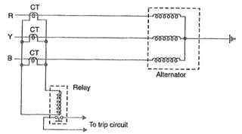

Fig. shows the schematic arrangement for the Protection of Alternators against unbalanced loading. The scheme comprises three line current transformers, one mounted in each phase, having their secondaries connected in parallel. A relay is connected in parallel across the transformer secondaries. Under normal operating conditions, equal currents flow through the different phases of the alternator and their algebraic sum is zero. Therefore, the sum of the currents flowing in the secondaries is also zero and no current flows through the operating [coil](http://www.allaboutcircuits.com/) of the relay. However, if unbalancing occurs, the currents induced in in the secondaries will be different and the resultant of these currents will flow through the relay. The operation of the relay will trip the circuit breaker to disconnect the alternator from the system.

**7. Stator winding faults:** These faults occur mainly due to the insulation failure of the stator windings. The main types of stator winding faults, in order of importance are :

* **fault between phase and ground**
* **fault between phases**
* **inter-turn fault involving turns of the same phase winding**

The stator winding faults are the most dangerous and are likely to cause considerable damage to the expensive machinery. Therefore, automatic protection is absolutely necessary to clear such faults in the quickest possible time in order to minimize the extent of damage. For Protection of Alternators against such faults, differential method of protection (also knows as **Merz-Price system**) is most commonly employed due to its greater sensitivity and reliability.

**Differential Protection of Alternators:**

The most common system used for the protection of stator winding faults employs circulating-current principle. In this scheme of Differential Protection of Alternators, currents at the two ends of the protected section are compared. Under normal operating conditions, these currents are equal but may become unequal on the occurrence of a fault in the protected section. The difference of the currents under fault conditions is arranged to pass through the operating coil of the relay. The relay then closes its contacts to isolate protected section from the system. This form of protection is also known as **Merz-Price Circulating Current Scheme**.

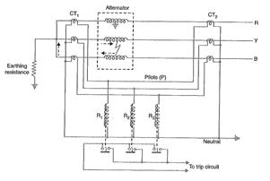

**Schematic arrangement:** Fig. shows the schematic arrangement of Differential Protection of Alternators for a 3-phase alternator. Identical current transformer pairs CT1 and CT2 are placed on either side of each phase of the stator windings. The secondaries of each set of current transformers are connected in star ; the two neutral points and the corresponding terminals of the two star groups being connected together by means of a four-core pilot cable. Thus there is an independent path for the currents circulating in each pair of current transformers and the corresponding pilot P.

The relay coils are connected in star, the neutral point being connected to the current-trans­former common neutral and the outer ends one to each of the other three pilots. In order that burden on each current transformer is the same, the relays are connected across equipotential points of the three pilot wires and these equipotential points would naturally be located at the middle of the pilot wires. The relays are generally of electromagnetic type and are arranged for instantaneous action since fault should be cleared as quickly as possible.

**Operation:** Referring to Fig. it is clear that the relays are connected in shunt across each circulating path. Therefore, the circuit of Fig. can be shown in a simpler form in Fig. 22.3. Under normal operating conditions, the current at both ends of each winding will be equal and hence the currents in the secondaries of two CTs connected in any phase will also be equal. Therefore, there is balanced circulating current in the pilot wires and no current flows through the operating coils (R1, R2 and R3) of the relays. When an earth-fault or phase-to-phase fault occurs, this condition no longer holds good and the differential current flowing through the relay circuit operates the relay to trip the circuit breaker.

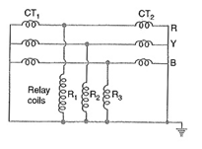

(i) Suppose an earth fault occurs on phase R due to breakdown of its insulation to earth as shown in Fig. The current in the affected phase winding will flow through the core and frame of the machine to earth, the circuit being completed through the neutral earthing resistance. The currents in the secondaries of the two CTs in phase R will become unequal and the difference of the two currents will flow through the corre­sponding relay coil (i.e. R1), returning via the neutral pilot. Consequently, the relay operates to trip the circuit breaker.

(ii) Imagine that now a short-circuit fault occurs between the phases Y and B as shown in Fig. The short-circuit current circulates via the neutral end connection through the two windings and through the fault as shown by the dotted arrows. The currents in the secondaries of two CTs in each affected phase will become unequal and the differential current will flow through the operating coils of the relays (i.e. R2 and R3) connected in these phases. The relay then closes its contacts to trip the circuit breaker

It may be noted that the relay circuit is so arranged that its energizing causes (i) opening of the breaker connecting the alternator to the bus-bars and (ii) opening of the field circuit of the alternator.

It is a prevailing practice to mount current transformers CT1 in the neutral connections (usually in the alternator pit) and current transformers CT2 in the switch-gear equipment. In some cases, the alternator is located at a considerable distance from the switchgear. As the relays are located close to the circuit breaker, therefore, it is not convenient to connect the relay coils to the actual physical midpoints of the pilots, Under these circumstances, balancing resistances are inserted in the shorter lengths of the pilots so that the relay tapping points divide the whole secondary impedance of two sets of CTs into equal portions. This arrangement is shown in Fig. These resistances are usually adjustable in order to obtain the exact balance.

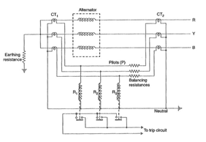

**Limitations:** The two circuits for alternator protection shown above have their own limitations. It is a general practice to use neutral earthing resistance in order to limit the destructive effects of earth-fault currents. In such a situation, it is impossible to protect whole of the stator windings of a star-connected alternator during earth-faults. When an earth-fault occurs near the neutral point, there may be insufficient voltage across the short-circuited portion to drive the necessary current round the fault circuit to operate the relay. The magnitude of unprotected zone depends upon the value of earthing resistance and relay setting.

Makers of protective gear speak of “protecting 80% of the winding” which means that faults in the 20% of the winding near the neutral point cannot cause tripping i.e. this portion is unprotected. It is a usual practice to protect only 85% of the winding because the chances of an earth fault occurring near the neutral point are very rare due to the uniform insulation of the winding throughout.

### ****Modified Differential Protection for Alternators:****

If the neutral point of a star-connected alternator is earthed through a high resistance, Modified Differential Protection of Alternators schemes shown in the above Fig. will not provide sufficient sensitivity for earth-faults. It is because the high earthing resistance will limit the earth-fault currents to a low value, necessitating relays with low current settings if adequate portion of the generator winding is to be protected. However, too low a relay setting is undesirable for reliable stability on heavy through phase-faults. In order to overcome this difficulty, a modified form of differential protection is used in which the setting of earth faults is reduced without impairing stability.

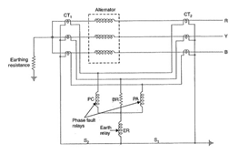

The modified arrangement is shown in Fig. The modifications affect only the relay connections and consist in connecting two relays for phase-fault protection and the third for earth-fault protection only. The two phase elements (PC and PA) and balancing resistance (BR) are connected in star and the earth relay (ER) is connected between this star point and the fourth wire of circulating current pilot-circuit.

**Operation:** Under normal operating conditions, currents at the two ends of each stator winding will be equal. Therefore, there is a balanced circulating current in the phase pilot wires and no current flows through the operating coils of the relays. Consequently, the relays remain inoperative.

If an earth-fault occurs on any one phase, the out-of-balance secondary current in CTs in that phase will flow through the earth relay ER and via pilot S1 or S2 to the neutral of the current transformers. This will cause the operation of earth relay only. If a fault occurs between two phases, the out of balance current will circulate round the two transformer secondaries via any two of the coils PA, BR, PC (the pair being decided by the two phases that are [faulty](http://www.allaboutcircuits.com/)) without passing though the earth relay ER. Therefore, only the phase-fault relays will operate.

**Balanced Earth Fault Protection:**

In small-size alternators, the neutral ends of the three-phase windings are often connected internally to a single terminal. Therefore, it is not possible to use Merz-Price circulating current principle described above because there are no facilities for accommodating the necessary current transformers in the neutral connection of each phase winding. Under these circumstances, it is considered sufficient to provide protection against earth-faults only by the use of Balanced Earth Fault Protection scheme. This scheme provides no protection against phase-to-phase faults, unless and until they develop into earth-faults, as most of them will.

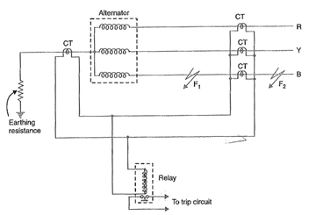

**Schematic arrangement:** Fig. shows the schematic arrangement of a Balanced Earth Fault Protection for a 3-phase alternator. It consists of three line current transformers, one mounted in each phase, having their secondaries connected in parallel with that of a single current transformer in the conductor joining the star point of the alternator to earth. A relay is connected across the transformers secondaries. The protection against earth faults is limited to the region between the neutral and the line current transformers.

**Operation:** Under normal operating conditions of Balanced Earth Fault Protection, the currents flowing in the alternator leads and hence the currents flowing in secondaries of the line current transformers add to zero and no current flows through the relay. Also under these conditions, the current in the neutral wire is zero and the secondary of neutral current transformer supplies no current to the relay.

If an earth-fault develops at F2 external to the protected zone, the sum of the currents at the terminals of the alternator is exactly equal to the current in the neutral connection and hence no current flows through the relay. When an earth-fault occurs at F1 or within the protected zone, these currents are no longer equal and the differential current flows through the operating coil of the relay. The relay then closes its contacts to disconnect the alternator from the system.

**Stator Inter Turn Protection:**

Merz-price circulating-current system protects against phase-to-ground and phase-to-phase faults. It does not protect against turn-to-turn fault on the same phase winding of the stator. It is because the current that this type of fault produces flows in a local circuit between the turns involved and does not create a difference between the currents entering and leaving the winding at its two ends where current transformers are applied. However, it is usually considered unnecessary to provide protection for inter-turn faults because they invariably develop into earth-faults.

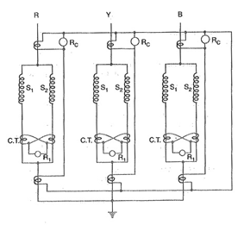

In single turn generator (e.g. large steam-turbine generators), there is no necessity of protection against inter-turn faults. However, inter-turn protection is provided for multi-turn generators such as hydro-electric generators. These generators have double-winding armatures (i.e. each phase winding is divided into two halves) owing to the very heavy currents which they have to carry. Advantage may be taken of this necessity to protect inter-turn faults on the same winding. Fig, shows the schematic arrangement of circulating-current and inter-turn protection of a 3-phase double wound generator. The relays RC provide protection against phase-to-ground and phase-to-phase faults whereas relays R1 pro­vide protection against inter-turn faults

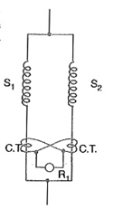

Fig. shows the duplicate stator windings S1 and S2of one phase only with a provision against inter-tum faults. Two current transformers are connected on the circulating-current principle. Under normal conditions, the currents in the stator windings S1 and S2 are equal and so will be the currents in the secondaries of the two CTs. The secondary current round the loop then is the same at all points and no [current](http://www.allaboutcircuits.com/) flows through the relay R1. If a short-circuit develops between adjacent turns, say on S1, the currents in the stator windings S1 and S2 will no longer be equal. Therefore, unequal currents will be induced in the secondaries of CTs and the difference of these two currents flows through the relay R1. The relay then closes its contacts to clear the generator from the system.

**Rotor Earth Fault Protection**

The rotor of the generator is normally unearthed i.e. remain isolated from the earth and therefore the single fault due to insulation breakdown will not rise the fault current. A single fault will not affect the rotor, but if the fault occurs, continues then it will damage the field winding of the generator. For a large generator, the rotor earth fault protection system is used for the protection of the field winding

When the one earth fault occurs in the rotor then it is not necessary that the system is completely trip, only the relay indicates that the fault has occurred. So that the generator should be taken out of service at leisure. The methods of rotor earth fault protection are explained below.

**Methods of Rotor Earth Fault Protection**

**Rotor Earth Fault Protection by Using High Resistance**

In this method, a high resistance is connected across the field winding of the rotor.The midpoint of the resistor is grounded through a sensitive relay. When the fault occurs the relay detect the fault and send the tripping command to the breaker.

The major disadvantage of such type of system it that it can detect the fault for most of the rotor circuit except the rotor centre point. This difficulty can be overcome by shifting the tap on the resistor from centre to somewhere else. Thus, the relay can detect the midpoint fault of the rotor.

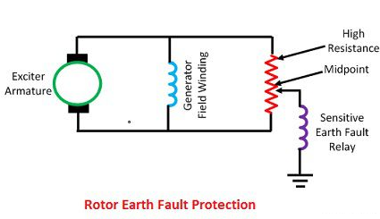

**AC and DC Injection Methods for Rotor Earth Fault Protection**

In this method, alternating current is injected into the field winding circuit and ground along with a sensitive overvoltage relay and a  current limiting capacitor. A single earth fault in the rotor will complete the circuit comprises the alternating current source, sensitive relay and earth fault. Thus, the earth fault is sensed by the relay.

The major disadvantage of such type of system is the leakage current that flows through the capacitor. This current unbalanced  the magnetic field and increase the stress on the magnetic bearing. Another disadvantage of alternating current is that the relay cannot pick up the current that normally flow through the capacitance to the ground. Thus, the care must be taken to avoid resonance between the capacitance and the relay inductance.

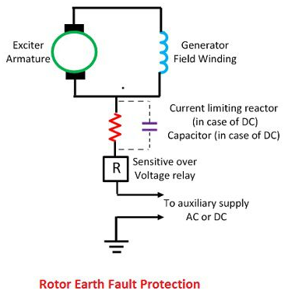

The problem of the AC injection system can be overcome by using the DC injection method. This method is simple and has no problem of leakage currents. The one terminal of the sensitive relay is connected to the exciter, and the other terminal is connected to the negative terminal of the DC source. The positive terminal of the DC source is grounded. When the earth fault occurs, the fault current will complete the circuit path, and the fault is sensed by the relay.

**PROTECTION OF TRANSFORMERS:**

Transformers are static devices, totally enclosed and generally oil immersed. Therefore, chances of faults occurring on them are very rare. However, the consequences of even a rare fault may be very serious unless the transformer is quickly disconnected from the system. This necessitates to provide adequate automatic Protection of Transformers against possible faults.

Small distribution transformers are usually connected to the supply system through series fuses instead of circuit breakers. Consequently, no automatic protective relay equipment is required. However, the probability of faults on power transformers is undoubtedly more and hence automatic protection is absolutely necessary.

**Common transformer faults:** As compared with generators, in which many abnormal conditions may arise, power transformers may suffer only from :

* open circuits
* overheating
* winding short-circuits g. earth-faults, phase-to-phase faults and inter-turn faults.

An open circuit in one phase of a 3-phase transformer may cause undesirable heating. In practice, relay protection is not provided against open circuits because this condition is relatively harmless. On the occurrence of such a fault, the transformer can be disconnected manually from the system.

Overheating of the transformer is usually caused by sustained overloads or short-circuits and very occasionally by the failure of the cooling system. The relay protection is also not provided against this contingency and thermal accessories are generally used to sound an alarm or control the banks of fans.

Winding short-circuits (also called **internal faults**) on the transformer arise from deterioration of winding insulation due to [overheating](https://www.eeeguide.com/switchgear-equipments/) or mechanical injury. When an internal fault occurs, the transformer must be disconnected quickly from the system because a prolonged arc in the transformer may cause oil fire. Therefore, relay protection is absolutely necessary for internal faults.

### ****Protection Systems for Transformers:****

For protection of generators, Merz-Price circulating-current system is unquestionably the most satisfactory. Though this is largely true of Protection of Transformers, there are cases where circulating current system offers no particular advantage over other systems or impracticable on account of the troublesome conditions imposed by the wide variety of voltages, currents and earthing conditions invariably associated with power transformers. Under such circumstances, alternative protective systems are used which in many cases are as effective as the circulating-current system. The principal relays and systems used for Protection of Transformers are :

* **Buchholz devices** providing protection against all kinds of incipient [faults](http://www.allaboutcircuits.com/) i.e. slow-developing faults such as insulation failure of windings, core heating, fall of oil level due to leaky joints etc.
* **Earth fault relays** providing protection against earth-faults only.
* **Overcurrent relays** providing protection mainly against phase-to-phase faults and overloading.
* **Differential system** (or circulating-current system) providing protection against both earth and phase faults.

The complete Protection of Transformers usually requires the combination of these systems. Choice of a particular combination of systems may depend upon several factors such as

* **Size of the trans­former**
* **Type of cooling**
* **Location of transformer in the network**
* **Nature of load supplied and**
* **Importance of service for which transformer is required.**

**Circulating Current Scheme for Transformer Protection:**

* Merz-Price Circulating Current Scheme for Transformer Protection is commonly used for the protection of power transformers against earth and phase faults. The system as applied to transformers is fundamentally the Stine as that for generators but with certain complicating features not encountered in the generator application. The complicating features and their remedial measures are briefed below :
* (i) In a power transformer, currents in the primary and secondary are to be compared. As these two currents are usually different, therefore, the use of identical transformers (of same turn ratio) will give differential current and operate the relay even under no load conditions.
* The difference in the magnitude of currents in the primary and secondary of power transformer is compensated by different turn ratios of CTs. If T is the turn-ratio of power transformer; then turn-ratio of CTs on the l.v. side is made T times that of the CTs on the h.v. side. Fulfilled this condition, the secondaries of the two CTs will carry identical currents under normal load conditions. Consequently, no differential current will flow through the relay and it remains inoperative.
* (ii) There is usually a phase difference between the primary and secondary currents of a 3-phase power transformer. Even if CTs of the proper turn-ratio are used, a differential current may , flow through the relay under normal conditions and cause relay operation.
* The correction for phase difference is effected by appropriate connections of CTs. The CTs on one side of the power transformer are connected in such a way that the resultant currents fed into the pilot wires are displaced in phase from the individual phase currents in the same direction as, and by an angle equal to Me:phase shift between the power-transformers primary and secondary currents. The table below shows the type of connections to be employed for CTs in order to compensate for the phase difference in the primary and secondary currents of power transformer.

[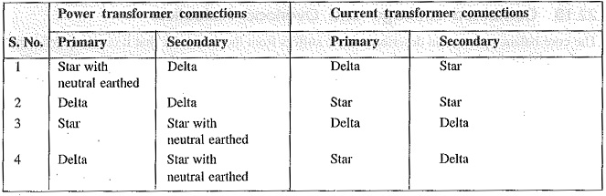](https://www.eeeguide.com/wp-content/uploads/2018/06/Circulating-Current-Scheme-for-Transformer-Protection.jpg)

* Thus referring to the above table, for a delta/star power transformer, the CTs on the delta side must be connected in star and those on the star side in delta.
* (iii) Most transformers have means for tap changing which makes this problem even more difficult. Tap changing will cause differential current to flow through the relay even under normal operating conditions.
* The above difficulty is overcome by adjusting the turn-ratio of CTs on the side of the power transformer provided with taps.
* (iv) Another complicating factor in Circulating Current Scheme for Transformer Protection is the magnetizing in-rush current. Under normal load conditions, the magnetizing current is very small. However, when a transformer is energized after it has been taken out of service, the magnetizing or in-rush current can be extremely high for a short period. Since magnetizing current represents a current going into the transformer without a corresponding current leaving, it appears as a fault current to differential relay and may cause relay operation.
* In order to overcome above difficulty, differential relays are set to operate at a relatively high degree of unbalance. This method decreases the sensitivity of the relays. In practice, advantage is taken of the fact that the initial in-rush currents contain prominent second-harmonic component. Hence, it is possible to design a scheme employing second-harmonic bias features, which, being tuned to second-harmonic frequency only, exercise restrain during energising to prevent maloperation.
* While applying circulating current principle for protection of transformers, above precautions are necessary in order to avoid inadvertent relay operation.
* Fig. shows Merz-Price circulating-current scheme for the protection of a 3-phase delta/delta power transformer against phase-to-ground and phase-to-phase faults. Note that CTs on the two sides of the transformer are connected in star. This compensates for the [phase](http://www.allaboutcircuits.com/) difference between the power transformer primary and secondary. The CTs on the two sides are connected by pilot wires and one relay is used for each pair of CTs.

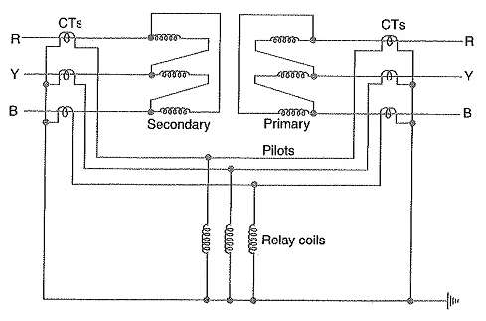

* During normal operating conditions, the secondaries of CTs carry identical currents. Therefore, the currents entering and leaving the pilot wires at both ends are the same and no current flows through the relays. If a ground or phase-to-phase fault occurs, the currents in the secondaries of CTs will no longer be the same and the differential current flowing through the relay circuit will clear the breaker on both sides of the transformer. The-protected zone is limited to the region between CTs on the high-voltage side and the CTs on the low-voltage side of the power transformer.
* It is worthwhile to note that this scheme also provides protection for short-circuits between turns on the same phase winding. When a short-circuit occurs between the turns, the turn-ratio of the power transformer is altered and causes unbalance between current transformer pairs. If turn-ratio of power transformer is altered sufficiently, enough differential current may flow through the relay to cause its operation. However, such short-circuits are better taken care of by Buchholz relays.

**Buchholz Relay:**

* Buchholz Relay is a gas-actuated relay installed in oil immersed transformers for protection against all kinds of faults. Named after its inventor, Buchholz, it is used to give an alarm in case of incipient (i.e. slow-developing) faults in the transformer and to dis­connect the transformer from the supply in the event of severe internal faults. It is usually installed in the pipe connecting the conservator to the main tank as shown in Fig. It is a universal practice to use Buchholz relays on all such oil immersed transformers having ratings in excess of 750 kVA.

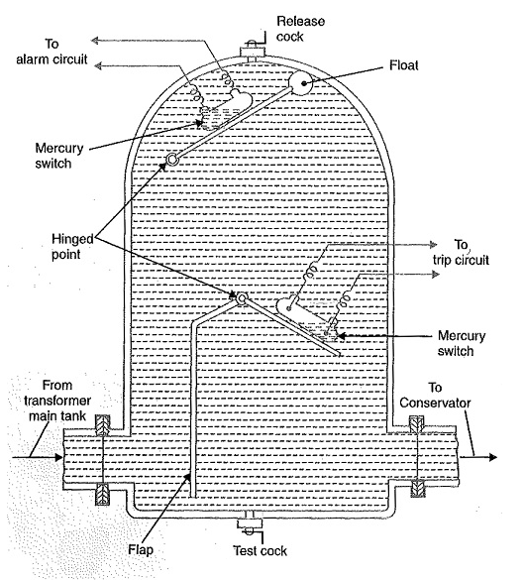

* **Construction:** Fig. shows the constructional details of a Buchholz relay. It takes the form of a domed vessel placed in the connecting pipe between the main tank and the conservator. The device has two elements. The upper element consists of a mercury type switch attached to a float. The lower element contains a mercury switch mounted on a hinged type flap located in the direct path of the flow of oil from the transformer to the conservator. The upper element closes an alarm circuit during incipient faults whereas the lower element is arranged to trip the circuit breaker in case of severe internal faults.

**Operation:**

The operation of Buchholz relay is as follows :

(i) In case of incipient faults within the transformer, the heat due to fault causes the decomposition of some transformer oil in the main tank. The products of decomposition contain more than 70% of hydrogen gas. The hydrogen gas being light tries to go into the conservator and in the process gets entrapped in the upper part of relay [chamber](http://www.allaboutcircuits.com/). When a pre­determined amount of gas gets accumulated, it exerts sufficient pressure on the float to cause it to tilt and close the contacts of mercury switch attached to it. This completes the alarm circuit to sound an alarm.

(ii) If a serious fault occurs in the transformer, an enormous amount of gas is generated in the main tank. The oil in the main tank rushes towards the conservator via the Buchholz relay and in doing so tilts the flap to close the contacts of mercury switch. This completes the trip circuit to open the circuit breaker controlling the transformer.

#### ****Advantages of Buchholz Relay:****

* It is the simplest form of transformer protection.
* It detects the incipient faults at a stage much earlier than is possible with other forms of protection.

#### ****Disadvantages of Buchholz Relay:****

* It can only be used with oil immersed transformers equipped with conservator tanks.
* The device can detect only faults below oil level in the transformer. Therefore, separate protection is needed for connecting cables.
* **Earth Fault Protection or Leakage Protection:**
* An Earth Fault Protection usually involves a partial breakdown of winding insulation to earth. The resulting leakage current is considerably less than the short-circuit current, The Earth Fault Protection may continue for a long time and cause considerable damage before it ultimately develops into a short-circuit and removed from the system. Under these circumstances, it is profitable to employ earth-fault relays in order to ensure the disconnection of Earth Fault Protection or Leakage Protection in the early stage.
* An earth-fault relay is essentially an overcurrent relay of low setting and operates as soon as an earth-fault or leak develops. One method of protection against earth-faults in a transformer is the **core-balance leakage protection** shown in Fig.

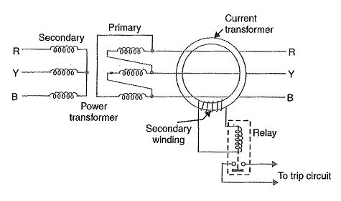

* The three leads of the primary winding of power transformer are taken through the core of a current transformer which carries a single secondary winding. The operating coil of a relay is connected to this secondary. Under normal conditions (i.e. no fault to earth), the vector sum of the three phase currents is zero and there is no resultant flux in the core of current transformer no matter how much the load is out of balance.
* Consequently, no current flows through the relay and it remains inoperative. However, on the occurrence of an, earth-fault, the vector sum of three phase currents is no longer zero. The resultant current sets up flux in the core of the C.T. which induces e. m. f. in the secondary winding. This energizes the relay to trip the circuit breaker and disconnect the faulty transformer from the system.

**Combined Leakage and Overload Protection:**

* The core-balance protection described above suffers from the drawback that it cannot provide protection against overloads. If a fault or leakage occurs between phases, the core-balance relay will not operate. It is a usual practice to provide combined leakage and overload protection for transformers. The earth relay has low current setting and operates under earth or leakage faults only. The overload relays have high current setting and are arranged to operate against faults between the phases.
* Fig. shows the schematic arrangement of combined leakage and overload protection. In this system of protection, two [overload](http://www.allaboutcircuits.com/) relays and one leakage or earth relay are connected as shown. The two overload relays are sufficient to protect against phase-to-phase faults. The trip contacts of overload relays and earth-fault relay are connected in parallel. Therefore, with the energizing of either overload relay or earth relay, the circuit breaker will be tripped.

